STRATEGY DOCUMENT

FOR

THE SOUTH AFRICAN WHEAT TO BREAD VALUE CHAIN

COMPILED FOR: THE WHEAT STEERING COMMITTEE

TABLE OF CONTENTS
No | Heading |  | P
 | Executive summary |  | 1
1 | Introduction |  | 4
2 | Historical perspective |  | 5
3 | Industry structure |  | 6
3.1 | Wheat production |  | 6
3.2 | Infrastructure providers |  | 7
3.3 | Traders |  | 8
3.4 | Millers |  | 8
3.4.1 | Wheat milled |  | 9
3.4.2 | Flour sales |  | 10
3.4.3 | Wheat milled and flour sales |  | 10
3.5 | Bakers |  | 11
3.6 | Retail sector |  | 11
3.7 | Value matrix diagram (P13) |  | 12
4 | International perspective and influences |  | 14
4.1 | African countries |  | 14
4.2 | Global Trade environment |  | 14
5 | SWOT Analysis |  | 17
5.1 | Wheat producers |  | 17
4.1.1 | Wheat producers – strengths |  | 17
5.1.2 | Wheat producers – weaknesses |  | 17
5.1.3 | Wheat producers – opportunities |  | 18
5.1.4 | Wheat producers – threats |  | 18
5.2 | Infrastructure suppliers |  | 18
5.2.1 | Infrastructure suppliers – strengths |  | 19
5.2.2 | Infrastructure suppliers – weaknesses |  | 19
5.2.3 | Infrastructure suppliers - opportunities |  | 19
5.2.4 | Infrastructure suppliers – threats |  | 19
5.3 | Traders: |  | 20
5.3.1 | Traders – strengths |  | 20
5.3.2 | Traders - weaknesses |  | 20
5.3.3 | Traders - opportunities |  | 20
5.3.4 | Traders - threats |  | 21
5.4 | Millers |  | 21
5.4.1 | Millers – strengths |  | 21
5.4.2 | Millers – weaknesses |  | 21
5.4.3 | Millers – opportunities |  | 21
5.4.4 | Millers – threats |  | 22
5.5 | Bakers |  | 22
5.5.1 | Bakers – strengths |  | 22
5.5.2 | Bakers – weaknesses |  | 22
5.5.3 | Bakers – opportunities |  | 23
5.5.4 | Bakers – threats |  | 23
6 | Proposed strategy for wheat to flour value chain |  | 23
6.1 | Vision |  | 23
6.2 | Mission |  | 24
6.3 | Objectives to achieve industry goals |  | 24
6.3.1 | Co-operation with government... |  | 25
6.3.1.1 | Trade & tariffs |  | 25
6.3.1.2 | Quality & standards |  | 25
6.3.1.3 | Information |  | 26
6.3.1.4 | Research |  | 26
6.3.1.5 | Infrastructure |  | 26
6.3.1.6 | General government bodies |  | 27
6.3.2 | Methods & standards for measuring. |  | 27
6.3.2.1 | Training |  | 27
6.3.2.2 | Technology |  | 28
6.3.2.3 | Government policies |  | 28
6.3.3 | Identify international market opportunities & analyse trade agreements, all to benefit of industry |  | 28
6.3.4 | Assist in development & participation of SMM, BEE and WE within the industry |  | 29
6.3.5 | Industry Initiative to assist Historically Disadvantage Individuals |  | 30
6.4 | Industry programmes |  | 31
7 | Conclusion |  | 33
 | Annexure A |  | 34
8.1 | Literate review of previous investigations on wheat to bread value chain
8.1.1 | Commission of enquiry into marketing Act – 1976 |  | 34
8.1.2 | Working Commission re the economic position of the farmer and agricultural financing in general (Jacobs) – 1978 |  | 35
8.1.3 | The inter departmental Committee regarding the establishment of bakeries (Brand) – 1978 |  | 35
8.1.4 | The BEPA Report regarding costs, advantages & financing of protection in SA – 1983 |  | 36
8.1.5 | The Commission of investigation into Government Subsidy on Bread (Davin) – 1985 |  | 37
8.1.6 | The Competition Board investigation into the milling and baking industry – 1985 |  | 37
8.1.7 | The NAMC investigation into the operation of the Winter Cereal Scheme – 1986 |  | 38
8.1.8 | Investigation into control over and support to the wheat and wheat processing enterprises abroad (Lamprechts, Alberts, de Villiers / Staden) – 1989 |  | 38
8.1.9 | Report of the Committee of investigation into phasing out of the Bread subsidy (Blignaut) – 1990 |  | 39
8.1.10 | Reports by the BTT into the price mechanism in the food chain with recommendations for its improvement - 1992 |  | 39
8.1.11 | The Report of the Committee of Inquiry into the Marketing Act (Kassier) – 1992 |  | 40
8.1.12 | Reports titled A framework for a future agricultural marketing policy for the RSA and the implementation thereof (Basson or AMPEC) – 1994 |  | 41
8.1.13 | LAPC, Bread price control and subsidies (Binen) –1996 |  | 42
8.1.14 | Business plan of the Wheat Board – 1996 |  | 43
8.1.15 | Wheat, Milling and Baking Cluster Atlas – 1997 |  | 43
8.1.16 | Report 3932 – Apr 1999 revision of the tariff dispensation on wheat, wheat flour and product . BTT. |  | 43
8.1.17 | NAMC sect 7 Committee – Evaluating the deregulation process: Wheat to bread value chain. Dec 1999 |  | 43
8.1.18 | Bureau of economic research: HIV/AIDS – Impact on Wheat Flour and Maize meal sales – 30 March 2001. |  | 44
8.1.19 | The Strategic plan for SA Agriculture (Sector plan) 27 Nov 2001 |  | 44
8.1.20 | Dr Ian Edwards (Austr): The SA Winter Grain Research Programme – evaluation of current status & future priorities May 2002 |  | 44
8.1.21 | Report to National treasury price behaviour in SA food & agricultural sector (Nick Vink & Johan Kirsten) Jun 2002 |  | 44
8.1.22 | Investigation into small and medium sized bakeries in SA – NCB & HSRC Jun 2002 |  | 44
8.1.23 | Competition Commission of SA – Final report inquiry into food price rises – Oct 2002 |  | 44
8.1.24 | SA Grain Industry sector plan – Nov 2003 |  | 44
8.2 | Annexure B |  | 44
 | Industry communications with government |  | 44
8.3 | Annexure C: Training courses |  | 45
8.3.1 | Silo industry |  | 45
8.3.2 | Milling industry |  | 45
8.3.3 | Baking industry |  | 46
8.4 | Annexure D |  | 47
 | Objectives for IRS and IHD |  | 47
8.5 | Annexure E |  | 48
 | Composition of the steering committee of the wheat forum?

A NEW WAY FORWARD FOR THE SOUTH AFRICAN WHEAT TO BREAD VALUE CHAIN

Executive Summary

The purpose of the wheat to bread value chain strategy is to enable a sustainable long term future for the stakeholders in the wheat industry. The vision of the South African wheat industry is to create within a free market environment, wheat to bread value chain that meets the needs of the domestic market effectively and efficiently and which is also competitive internationally. This can be achieved through the members of the value chain working together to develop synergies in partnership with government which will ensure the long term growth and prosperity of the wheat industry. The industry will also work towards attracting and making investments that will create substantial employment through a multifaceted supply chain.

Wheat products are being used by government to drive the fortification programme, with bread forming part of government’s vehicle to ensure food security. This reflects one of the important roles that are played by the value chain in the South African food industry.

Up to 1997 wheat prices were fixed, imports and exports controlled while millers were obliged to take up all locally produced wheat. Since deregulation (post 1997) the only protection the industry enjoys is in the form of tariffs. The South African wheat industry is at present one of the freest in the world.

The stakeholders are convinced that there is a positive future for both the wheat industry and the economy at large. To achieve this, the industry must recognize that inter alia the following changes need to be made. Firstly, the stakeholders will need to make changes to their traditional ways of approaching business. Secondly, there need to be total commitment to meeting the needs of the market. Thirdly, stakeholders need to align their business plans to government’s goals. Fourthly, government should take industry’s needs into consideration when formulating policies.

Wheat is the second most important field crop in South Africa and together with the secondary processing industries provides a large number of job opportunities. South Africa has about 3 800 to 4 000 commercial wheat farmers providing work opportunities to about 28 000 people.

Government (Department of Agriculture), the Maize Board, Wheat Board, Oilseeds Board and Sorghum Board decided jointly on the establishment of grain silos and the capacity thereof. A loan scheme was operated by the Land Bank to encourage the building of silos. Within the set guidelines of the Grain Silo Committee silos with a capacity of 15,5million tons (maize equivalent) were built at 220 depots in the north (Highveld) and 972 856 tons at 46 depots in the south (Western Cape).There are currently 16, 9 million tons bulk storage capacity available of which 85% of silo capacity is owned by former co-operatives.

The number of wheat mills in South Africa has dropped from 137 mills in 1996/97 to 103 mills to date. While 90 small mills have been established, 33 of the larger mills still produce approximately 97% of South Africa’s wheat flour. The milling capacity of the wheat milling industry is 406 tons per hour and capacity utilization is 78%. From 1992 to 1998 employment has decreased by 25% in the milling industry as a result of improved efficiency and milling units being closed. The new small entrants into the market are creating new employment opportunities, but from a low base. This is not sufficient to counter the negative impact of the losses at the large mills. The total capital investment in the milling industry is approximately R3 billion and it employs around 3 800 people. In the last 10 years the average milling output was around 2.5 million tons per year with annual flour sales of about 2.0 million tons and 0.5 million tons of bran (animal feed).

At the time of deregulation of the baking industry there were approximately 3 000 bakeries registered with the Wheat Board. 80% of the bread production was in the hands of six groups. Currently the number of baking units in South Africa is estimated at 7 900 formal bakers and around 64 900 informal bakers. Growth in this industry took place through the establishment of franchise and in-store bakeries.

The major product of the baking industry is bread. 70 to 80 percent of all flour milled is used for bread baking. The industry is the second most important supplier of energy (kilojoules) in the national diet after maize meal. Annual consumer expenditure on bread is, however, higher than on maize products. This was estimated at R6,7 billion in 2000 compared to an expenditure of R6,2 billion for maize products.

Since the abolishment of price control in March 1991, the retail sector’s share of the actual price of bread has grown from 3% to 12% in 1998/1999. When VAT was introduced in 1998/99 government share rose from 0 to 12% for white bread while brown bread is VAT exempted.

World wheat production for the past four years has averaged 585 million tons of which about 60% is produced in four countries. These are China (18,9%), the European Union (17,7%), the United States of America (11,8%) and India (11,2%). The international market for wheat and wheat flour has been distorted by government intervention for an extended period of time through measures such as direct producer support and export subsidies. These have been aimed primarily at maintaining national production capacities and removal of surplus production. In order to maintain the competitive edge for their value-adding milling and baking sectors, export refunds, mostly based on wheat content, are paid by some major wheat producing countries. This situation makes it difficult for developing countries such as South Africa to compete internationally since our prices without subsidies are higher than those of wheat produced by developed countries.

The mission of the South African wheat industry is to become a long term preferred supplier of wheat, wheat flour and wheat based products to the domestic market and to selected international markets which necessitates the industry to become driven by the needs and characteristics of its target markets.

After extensive analysis and ongoing discussions between all role players, a number of objectives as set out below were identified. These objectives are seen as being the gateway to achieve success for the wheat value chain and matching the vision and mission statements of the industry:

- Co-operate with government and government agencies and obtain their active support to achieve short and long term industry goals
  - Trade and Tariffs
  - Quality and Standards
  - Information
  - Research
  - Infrastructure
  - General government issues

- The entire value chain must put in place methods of best practice and set standards against which they can constantly be measured
  - Training: Develop appropriate skills in all sectors
  - Technology: Use of world class technology

- Identify international marketing opportunities and monitor and analyse the trade agreements, all to the benefit of the industry
  - Formation of export council/Joint Action Groups.
  - Involvement in NEPAD initiative.
  - Involvement with government in trade agreements.
  - Gain access to international data base.
  - Develop skills to deal with export and import issues.
  - Economic research on tariff policies

- Assist in the development of, and participation in, Black Economic Empowerment (BEE’s), Small, Medium and Micro Enterprises (SMME’s) and Women Owned Enterprises (WE) within the industry
  - Outsourcing some opportunities to BEE’s, SMME’s & WE.
  - Provide technical and management assistance.
  - Co-operate with government to assist financially and technically.
  - Training.
  - Assist with procurement of inputs.
  - Assist in logistic and marketing of their products

1. INTRODUCTION

This document presents a strategy for the wheat to bread value chain to ensure that it has a sustainable long-term future, which is in the best interests of all its stakeholders and the economy at large.

A sound and growing wheat industry has the potential to attract investment and to provide substantial employment directly and indirectly for thousands of people as it impacts through a multifaceted supply chain. This includes farmers, silo operators, traders, manufacturers, bakers, retailers, input suppliers and support services which all contribute to this industry. The industry turnover is estimated at around R22 billion.

Bread is an important staple food in South Africa. It thus forms an integral part of the South African government’s strategy to ensure household food security. This was underlined in its selection as one of the most important vehicles to carry the fortification programme to the masses through the use of fortified flour in bread baking. The international intervention in the wheat to bread value chain also highlights the importance of this staple food internationally as part of food security.

Agri South Africa, NAFU and the National Department of Agriculture concluded a range of negotiations in formulating a strategic plan for South African agriculture. This is an important pillar in the economic growth and strategic plan of the Government for economic growth and job creation. The wheat to bread value chain also forms an integral part of this agricultural sector plan.

Flowing from the agricultural sector plan, the National Department of Agriculture is currently (Nov 2003) taking the initiative in formulating a grain sector plan based on the objectives of the agriculture sector plan. This process is reaching its concluding consultation period and will probably be finalised early in 2004.

The stakeholders are convinced that there is a positive future for both the industry and the economy at large. To achieve this, the industry must recognize that inter alia the following changes need to be made. Firstly, the stakeholders will need to make some changes to their traditional ways of approaching their business. Secondly, there will need to be unswerving and total commitment to meet the needs of the market. Thirdly, stakeholders need to align their business plans to government’s goals. Fourthly, government should consider industry needs when formulating policies.

Since 1997, the South African market has probably been one of the freest grain markets operating in the world economy today. The local industry is faced with stiff competition from the developed countries which enjoy significant support from their governments either in the form of production subsidies or export assistance.

Before presenting strategies that can ensure growth and sustainability of the industry, it is important to appreciate what happened to the industry in the past years up to date.

2. HISTORICAL PERSPECTIVE

Prior to deregulation in 1997, marketing of wheat was regulated through a single channel marketing system administered by the Wheat Board. The Board was sole buyer and seller of wheat at predetermined prices and also controlled imports and exports of wheat and wheat flour. Millers were obliged to take up all locally produced wheat for milling. The flour price was fixed by the Wheat Board up to 1991, with available wheat allocated to millers according to milling capabilities and the location of the wheat.

The production and marketing environment in this value chain has changed radically since deregulation. Since the abolishment of the single channel marketing system and import control (1997), tariffs have become the only protection against imports of wheat and wheat flour, giving rise to restructuring of both the primary and secondary industries. From 1991 the Wheat Board no longer fixed the flour and bread price although the production price of wheat was still controlled. The bread subsidy by government was also abolished in March 1991 and value added tax on white bread introduced. The Wheat Forum was established in 1994 to guide the industry with, inter alia, the deregulation process and to provide equitable participation of all role players in the value chain.

Since the termination of price control after March 1991, the retail sector’s share in the price of loaf of bread has more than quadrupled, while the government share in the same period rose from 0 to 12.16% due to the introduction of value added tax on white bread.

There is a clear focus on improved client services reflecting a paradigm shift in the value chain to favour the consumer. Today the industry has become more consultative and co-operative when it comes to decision making especially in terms of research, information services, quality standards, trade related matters, etc.

The SA Futures Exchange (SAFEX) for agricultural products was established in the free market environment as a hedging instrument. The futures prices formed through trading on SAFEX are used as price indicators in the trade.

SAFEX is presently a division of the Johannesburg Stock Exchange (JSE).

3. INDUSTRY STRUCTURE

3.1 Wheat production

Wheat is the second most important field crop in South Africa and together with secondary processing industries provides a large number of job opportunities. South Africa has about 3 800 to 4 000 commercial wheat farmers providing work opportunities to about 28 000 people.

Table 1: Average Wheat production and yield By Province: 1992-2002

Region | Area  Hectares  (‘000) | % | Production  Tons  (‘000) | % | Yield  Ton/ha
Western Cape  Northern Cape  Free State  Eastern Cape  KwaZulu Natal  Mpumalanga  Limpopo  Gauteng  North West | 357.1  52.8  514.7  8.2  6.4  15.7  13.4  2.8  40.3 | 35.3  5.2  50.9  0.8  0.6  1.5  103  0.3  4.0 | 673.31  282.52  768.30  15.16  29.56  73.25  49.02  11.55  136.93 | 33.0  13.9  37.7  0.7  1.4  3.6  2.4  0.6  6.7 | 1.9  5.4  1.6  2.2  4.5  4.7  3.7  4.3  3.8
Total wheat | 1 011.3 | 100.0 | 2 039.59 | 100.0 | 2.1
Source: National Crop Estimate

Table 2: Exports and Imports of Wheat

 | 1997/98 | 1998/99 | 1999/00 | 2000/01 | 2001/02 | 2002/03
Exports (‘000) | 79 | 75 | 72 | 103 | 138 | 177
Imports (‘000) | 469 | 484 | 624 | 308 | 408 | 747
Net Imports (‘000) | 390 | 409 | 552 | 205 | 270 | 570

Source: SAGIS

Figure 1: Local Production, Import s and Exports

Local Wheat Production, Imports and Exports
2449
1884
1725
2353
2416
469
408
308
484
624
79
75
138
103
72
0
500
1000
1500
2000
2500
3000
97/98
98/99
99/00
00/01
01/02
YEARS
'000 TONS
Production
Imports
Exports
Source: SAGIS
Figure 1 reflects the SA industry position of wheat against imports.

3.2 Infrastructure providers

The Government (Department of Agriculture), the Maize Board, Wheat Board, Oilseeds Board and Sorghum Board decided jointly on the establishment of grain silos and the capacity thereof. A loan scheme was operated by the Land Bank to encourage the building of silos. Within the set guidelines of the Grain Silo Committee silos with a capacity of 15,5 million tons (maize equivalent) were built at 220 depots in the north (Highveld) and 972 856 tons at 46 depots in the south (Western Cape). There is currently 16,9 million ton bulk storage capacity available of which 85% of silo capacity is owned by former co-operatives.

The marketing boards administered a single channel fixed price marketing system, determined the grading regulations, were responsible for distribution and regulated the transport of grains and oilseeds and remunerated the silo owners who operated the silos as agents of the boards. The Wheat Board specifically handled the administration and distribution arrangements for wheat.

Since deregulation, grains and oilseeds have been marketed within a free market system. Producers/owners of grains and oilseeds can sell to whom they want and can deliver their produce directly to processors. They can also store their produce on farms.

Imports are not controlled any more and producers have to compete on the international market.

Since deregulation the silo owners have been under economic pressure as they have to operate within a free market system, compete with other storers of grain and oilseeds and have a lower throughput from which they have to derive their income. Transport by road has increased dramatically and this leads to out loading problems as silos were constructed to primarily dispatch by rail. The deregulated situation with multiple owners of stored wheat and diversity of information required means more sophisticated and costly administration by silo owners.

3.4 TRADERS

The Agricultural Products Division of the JSE Securities Exchange.

The Agricultural Products Division of the JSE Securities Exchange, South Africa, started its existence as the Agricultural Markets Division of the South African Futures Exchange (SAFEX) in 1995. It became part of the JSE in August 2001 when SAFEX was bought out by the JSE. A separately capitalized entity with its own membership was established by the issue of 84 trading seats under the umbrella of SAFEX, a financial derivatives market operating in terms of the Financial Markets Control Act.

The Agricultural Markets Division traded its first contract in chilled carcass beef in August 1995, but the chilled beef, and later, the potato futures contracts never took off and the focus soon shifted to introducing futures contracts on maize. Futures contracts on white and yellow maize were listed in March 1996 and futures contracts on wheat were introduced in November 1997. Options on these contracts followed in March 1998. Today, futures and options are also traded on sunflower seeds and soya.

Initially, trading was limited, but as the understanding of the market instruments increased so did trading volumes. Today an average of over 8000 contracts is traded on a daily basis. During 2003, a total of 2,3 million contracts traded on the market – an average of over 190 000 contracts per month. At present there are 62 members comprising commercial banks, commodity traders, financial traders and agriculture related companies. The clearing operation of the market is undertaken by four banks that guarantee the trade. The market is widely used by participants across the sector and the prices discovered on the market are used as reference prices for both the region and the world.

3.3 Millers

The number of wheat mills in South Africa has dropped from 137 mills in 1996/97 to 103 mills to date. While 90 small mills have been established, 33 of the larger mills still produce 97% of South Africa’s wheat flour. The milling capacity of the wheat milling industry is 406 tons per hour and capacity utilization is 78%. From 1992 to 1998 employment has decreased by 25% in the milling industry as a result of improved efficiency and milling units being closed. The new small entrants into the market are creating new employment opportunities, but on a low basis and not fast enough to counter the negative impact of the losses at the large mills.

The total capital investment in the milling industry is approximately R3 billion and it employs around 3 800 people. In the last 10 years the average milling output was around 2.5 million tons per year with annual flour sales of about 2.0 million tons and 0.5 million tons of bran (animal feed).

The South African flour exports into the South African Customs Union (SACU) and the Southern African Development Community (SADC) regions show a slow increase due to low priced imported flour from the West and East either in the form of subsidised imports or donations. This situation is further aggravated by wheat imported from outside the SACU subject to a rebate on import duty.

3.3.1 Wheat Milled

Table 3: Monthly wheat milling in tons

Months | 2002/03 | 2001/02 | 2000/01 | 1999/2000 | 1998/99 | 1997/98
November | 212 757 | 204 316 | 203 780 | 199 942 | 207 298 | 204 021
December | 197 394 | 193 865 | 186 174 | 179 539 | 193 082 | 197 204
January | 182 201 | 214 148 | 192 120 | 167 955 | 170 452 | 185 932
February | 164 264 | 181 409 | 169 817 | 173 710 | 169 519 | 182 503
March | 193 507 | 191 740 | 196 056 | 189 522 | 185 736 | 197 325
April | 186 346 | 190 358 | 172 634 | 165 827 | 168 696 | 179 391
May | 209 632 | 203 004 | 214 046 | 215 530 | 202 709 | 188 832
June | 211 029 | 198 387 | 212 549 | 195 859 | 179 018 | 176 912
July | 204 749 | 213 445 | 189 982 | 193 388 | 196 239 | 190 046
August | 198 942 | 200 216 | 200 400 | 206 277 | 200 542 | 209 750
September | 208 981 | 210 521 | 197 127 | 180 349 | 181 633 | 183 720
October | 216 343 | 219 805 | 211 513 | 219 468 | 205 930 | 205 597
TOTAL | 2 386 145 | 2 421 213 | 2 346 197 | 2 287 365 | 2 260 853 | 2 301 234
Source: NCM – Monthly Statistics (+/- 97% of total market)

Table 3 reflects South Africa’s capability to maintain stable production even under strong pressure from market forces.

3.3.2 Flour Sales

Table 4: Monthly flour sales in tons

Months | 2002/03 | 2001/02 | 2000/01 | 1999/2000 | 1998/99 | 1997/98
November | 157 338 | 165 392 | 161 682 | 155 657 | 155 714 | 156 274
December | 158 791 | 157 594 | 155 303 | 150 016 | 161 833 | 161 393
January | 136 735 | 162 376 | 140 881 | 120 510 | 122 485 | 134 513
February | 127 682 | 136 773 | 137 998 | 142 530 | 127 740 | 138 565
March | 153 459 | 148 782 | 158 728 | 150 578 | 144 269 | 163 256
April | 151 290 | 149 972 | 141 308 | 139 297 | 126 735 | 142 683
May | 159 727 | 155 890 | 165 786 | 167 281 | 145 674 | 141 553
June | 160 766 | 155 041 | 155 346 | 156 694 | 137 825 | 139 055
July | 162 355 | 166 986 | 147 860 | 155 169 | 148 277 | 147 099
August | 151 997 | 158 040 | 155 011 | 158 782 | 168 427 | 149 263
September | 161 185 | 165 200 | 161 064 | 143 220 | 150 764 | 135 871
October | 164 017 | 165 496 | 162 140 | 170 525 | 157 243 | 152 069
TOTAL | 1 845 342 | 1 887 543 | 1 843 107 | 1 810 259 | 1 746 987 | 1 761 592

Source: NCM – Monthly Statistics
Table 4 reflects average sales of 1.8 million tons of flour and meal for the past six years

3.3.3 Wheat Milled and Flour Sales

Figure 2
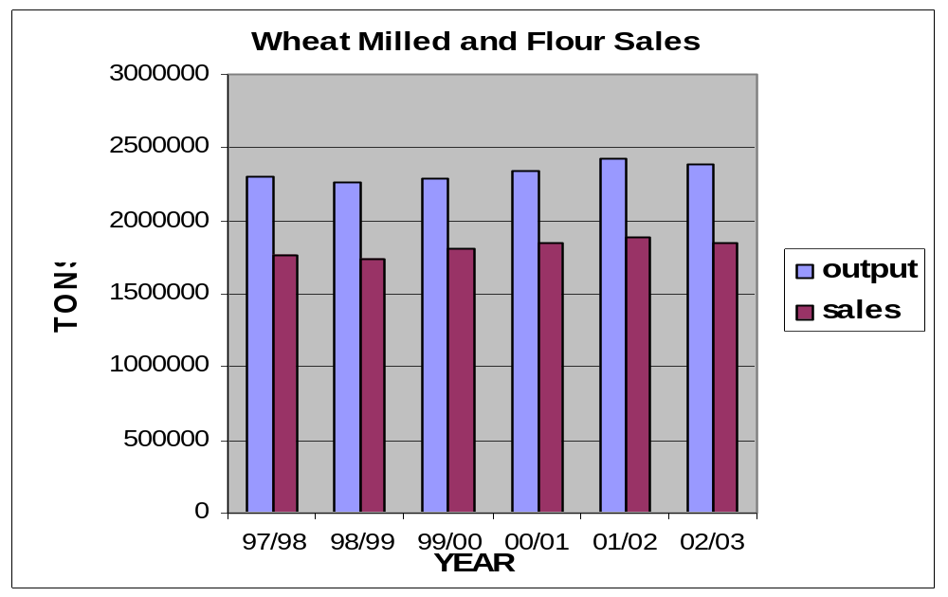
Source: NCM – Monthly Statistics
The difference between output and sales in terms of figure 2 goes to the animal feed for dairy, poultry, red meat and other related industries.

3.4 Bakers

At the time of deregulation of the baking industry there were approximately 3 000 bakeries registered with the Wheat Board. Eighty percent of the bread production was in the hands of six groups. Currently the number of baking units in South Africa is estimated at 7 900 formal bakers and around 64 900 informal bakers. Growth in this industry took place through the establishment of franchise and in-store bakeries.

The major product of the baking industry is bread and 70 to 80 percent of all flour produced is used for bread baking. The industry is the second most important supplier of energy (kilojoules) in the national diet after maize meal. Annual consumer expenditure on bread is, however, higher than on maize products. This was estimated at R6 700 million in 2000 compared to an expenditure of R6 200 million for maize products.

Bread is readily available throughout the country and a national survey of retail outlets indicated that bread has almost 100% representation in all stores selling groceries.

National bread consumption is estimated at 2 800 million loaves per annum or approximately 62 loaves per person per annum. There are, however, considerable differences between the provinces in terms of total consumption and preference for white or brown bread. For example, the per capita consumption in Gauteng is 86 loaves per annum compared to 44 loaves in Limpopo. In the Western Cape 76% of all bread eaten is white bread. In Limpopo, however, 25% of the bread eaten is white and the balance is brown bread.

The Baking Industry has become very consumer driven since deregulation which has resulted in considerable product development and diversification. Bread, for example, is seldom sold unwrapped today and sliced wrapped bread is the most popular product sold. The range of categories of bread sold and other confectionery products offered to the consumer has grown dramatically since deregulation.

For a detailed study see the Wheat, Milling and Baking Cluster Atlas – Annexure A. A further reference document is ‘Investigation into the Development of Small and Medium Sized Bakeries in South Africa’, published in June 2002.

3.5 Retail sector

Since the abolishment of price control in March 1991, the retail sector’s share of the actual price of bread has grown from 3% to 12% in 1998/1999. When VAT was introduced government share rose from 0 to 12% for white bread in 1998/99 while brown bread is VAT exempted.

A detailed study was carried out to look at the critical issues and challenges facing the value chain: Wheat, Milling and Baking Cluster Atlas – Annexure A.

3.6 Value matrix diagram – Page 13

Power
Water
Yeast
Oil
Sugars
Dairy
Meat
Fruit/Veg.
Preservatives Vitamins
Value System — Wheat, Milling and Baking
Capital Equipment
Finance
Import / Export Services
Industry Associations
Infrastructure (roads, water etc.)
Insurance
Labour
Logistics
Maintenance Services
*Related and Supporting Industries
Traders
Packaging
Quality Control
R&D
Training
Transport Equipment
Transport Services (road rail, shipping)
Unions

Grading & Quality control
Education
Health
Prisons
Hotels
Supermarkets
OTC and In store bakeries
Cafes and spazas
Rural plant bakery stores
SADC
Non SADC
Related & Supporting*
Distribution
Marketing
Wheat
Biscuits
Pasta
Crackers
Breakfast Cereals
Other
Farm Feeds
Pet Food
Other
Land
Seed
Fertiliser
Lime
Water
Fuel
Pesticides
Institutions
Irrigation
Farming Equipment
Related & Supporting*
Related & Supporting*
Road & Rail Infrastructure
Transport
Process Control
Traders
Chemicals Power
Power
Water
Packaging
Transport
Training
Standards/ Quality Control
Packaging
Training
Related &
Supporting*
Poultry & Red Meat Farming
Finance
Imported Wheat
Imported Wheat
Land
Power
Water
Oil
Sugars
Dairy
Meat
Fruit/Veg.
Preservatives
Vitamins
Power
Water
Oil
Sugars
Dairy
Meat
Fruit/Veg.
Preservatives
Vitamins
Imported Flour
Imported Flour
Export Distribution
Rural & Urban Retail
Imported Goods
Perishable Products
Pan Loaves
Speciality breads
Rolls/Buns
Confectionery products
Other
Other Products
Frozen dough
Par baked products
Milling
Wheat Based Goods Mfg.
Animal Feed
Manufacture
Wheat
Farming
Storage
Wholesalers
Baking
Flour
Meal
Bran
Traders
Government Support
NDA DOL
DTI DOT
Spoornet PDA’s
DOH Landbank

4. INTERNATIONAL PERSPECTIVE AND INFLUENCES

4.1 African countries

South Africa has a self-sufficiency wheat production index of about 92%, while Sub-Saharan and North Africa have self-sufficiency indices of less than 50% on average. South Africa produces 50% of Sub-Saharan wheat and over 80% of the SADC production.

Table 5: Wheat Production and requirements

SADC: Wheat Production and Requirement in thousand metric tons for the past two years
Country | 2001/2002 |  | 2002/2003
 | Production | Requirement | Production | Requirement
Angola | 0 | 210 | 0 | 210
Botswana | 0 | 61 | 0 | 78
Lesotho | 18 | 113 | 15 | 96
Malawi | 2 | 31 | 2 | 50
Mauritius | 0 | 91 | 0 | 91
Mozambique | 0 | 231 | 0 | 282
Namibia | 5 | 68 | 10 | 53
South Africa | 2 503 | 2 550 | 2 292 | 2 645
Swaziland | 0 | 46 | 0 | 44
Tanzania | 90 | 171 | 77 | 176
Zambia | 75 | 116 | 75 | 112
Zimbabwe | 360 | 364 | 160 | 398
TOTAL | 3,053 | 4,052 | 2,631 | 4,235
Source: SADC REWU
Dated: 28/04/2003

Annual wheat production in other SACU countries is estimated at 30 000 tons while demand is estimated to be 250 000 tons. Production in the rest of the SADC countries amounts to 473 000 tons with Zimbabwe (13%), Tanzania (4%) and Zambia (3%) being other main contributors as reflected in Table 5. On the other hand, total production for South Africa for 2002/03 is about 2 292 000 tons with local demand of about 2 645 000 tons. Despite the estimates by the SADC Secretariat of 2, 6 million tons as above, our local demand is 2, 5 million tons.

4.2 Global Trade Environment

South Africa is a net importer of wheat and has to import wheat 9 out of every 10 seasons. Being a net importer of wheat, wheat prices in South Africa tends to be based on import parity (landed cost of international wheat in South Africa, including the wheat tariff).

World wheat production for the past four years has averaged 585 million tons of which about 60% is produced in four countries. These are China (18,9%), the European Union (17,7%), the United State of America (11,8%) and India (11,2%). The international market for wheat and wheat flour has been distorted for an extended period of time by government intervention through measures such as direct producer support and export subsidies, primarily aimed at maintaining national production capacities and removal of surplus production. In order to maintain the competitive edge for their value-adding milling and baking sectors, export refunds, mostly based on wheat content, are paid by some major wheat producing countries. This situation makes it difficult for developing countries such as South Africa to compete internationally since our prices without subsidies are higher than those of wheat produced by developed countries.

As an industry it is hoped that trade liberalisation in the end will afford new opportunities to developing countries to compete on an equal footing with developed countries. The industry aims to take up a certain percentage of the international market through our competitive export drive. Whilst the matters of agricultural subsidies and farmer support have not been resolved, the industry believes that South Africa should adopt a tariff protection policy until international subsidy reductions actually make a difference in world prices.

Figure 3 is a presentation of the level of support, measured in the Producer Support Estimate (PSE), which farmers receive from their governments. The PSE is the support as a percentage of gross farm receipts. South Africa will probably fall in the category of New Zealand, Australia and Poland since we have discontinued all forms of production support, where other Developed Countries as seen in Figure 3 like Japan, Iceland, Korea, etc. have maintained the subsidies more than 40%.

Figure 3
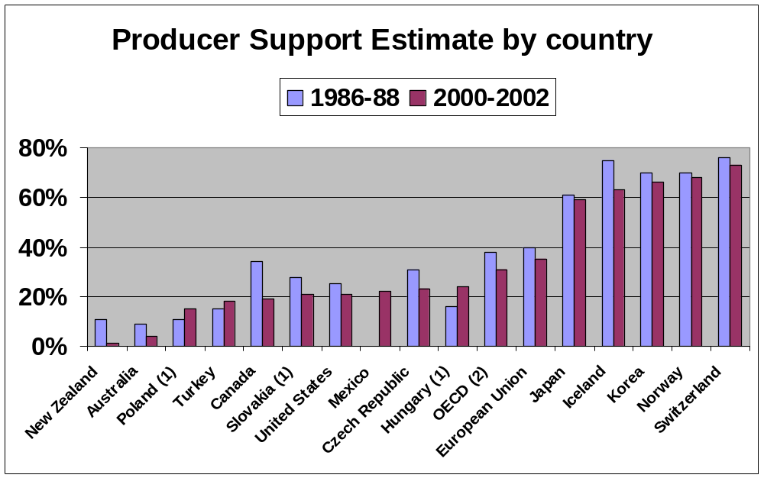

Source: OECD

If the same data (PSE) is analysed on a per product basis, Figure 4 indicated that only rice, sugar and milk receive more government support than grain and wheat. History proves that wheat flour export subsidies exceed that of wheat by far.

Figure 4
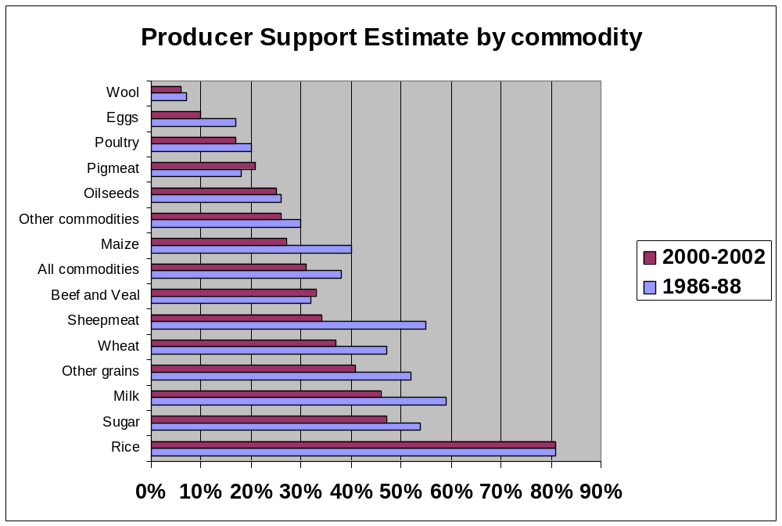
SOURCE: OECD

Figure 5
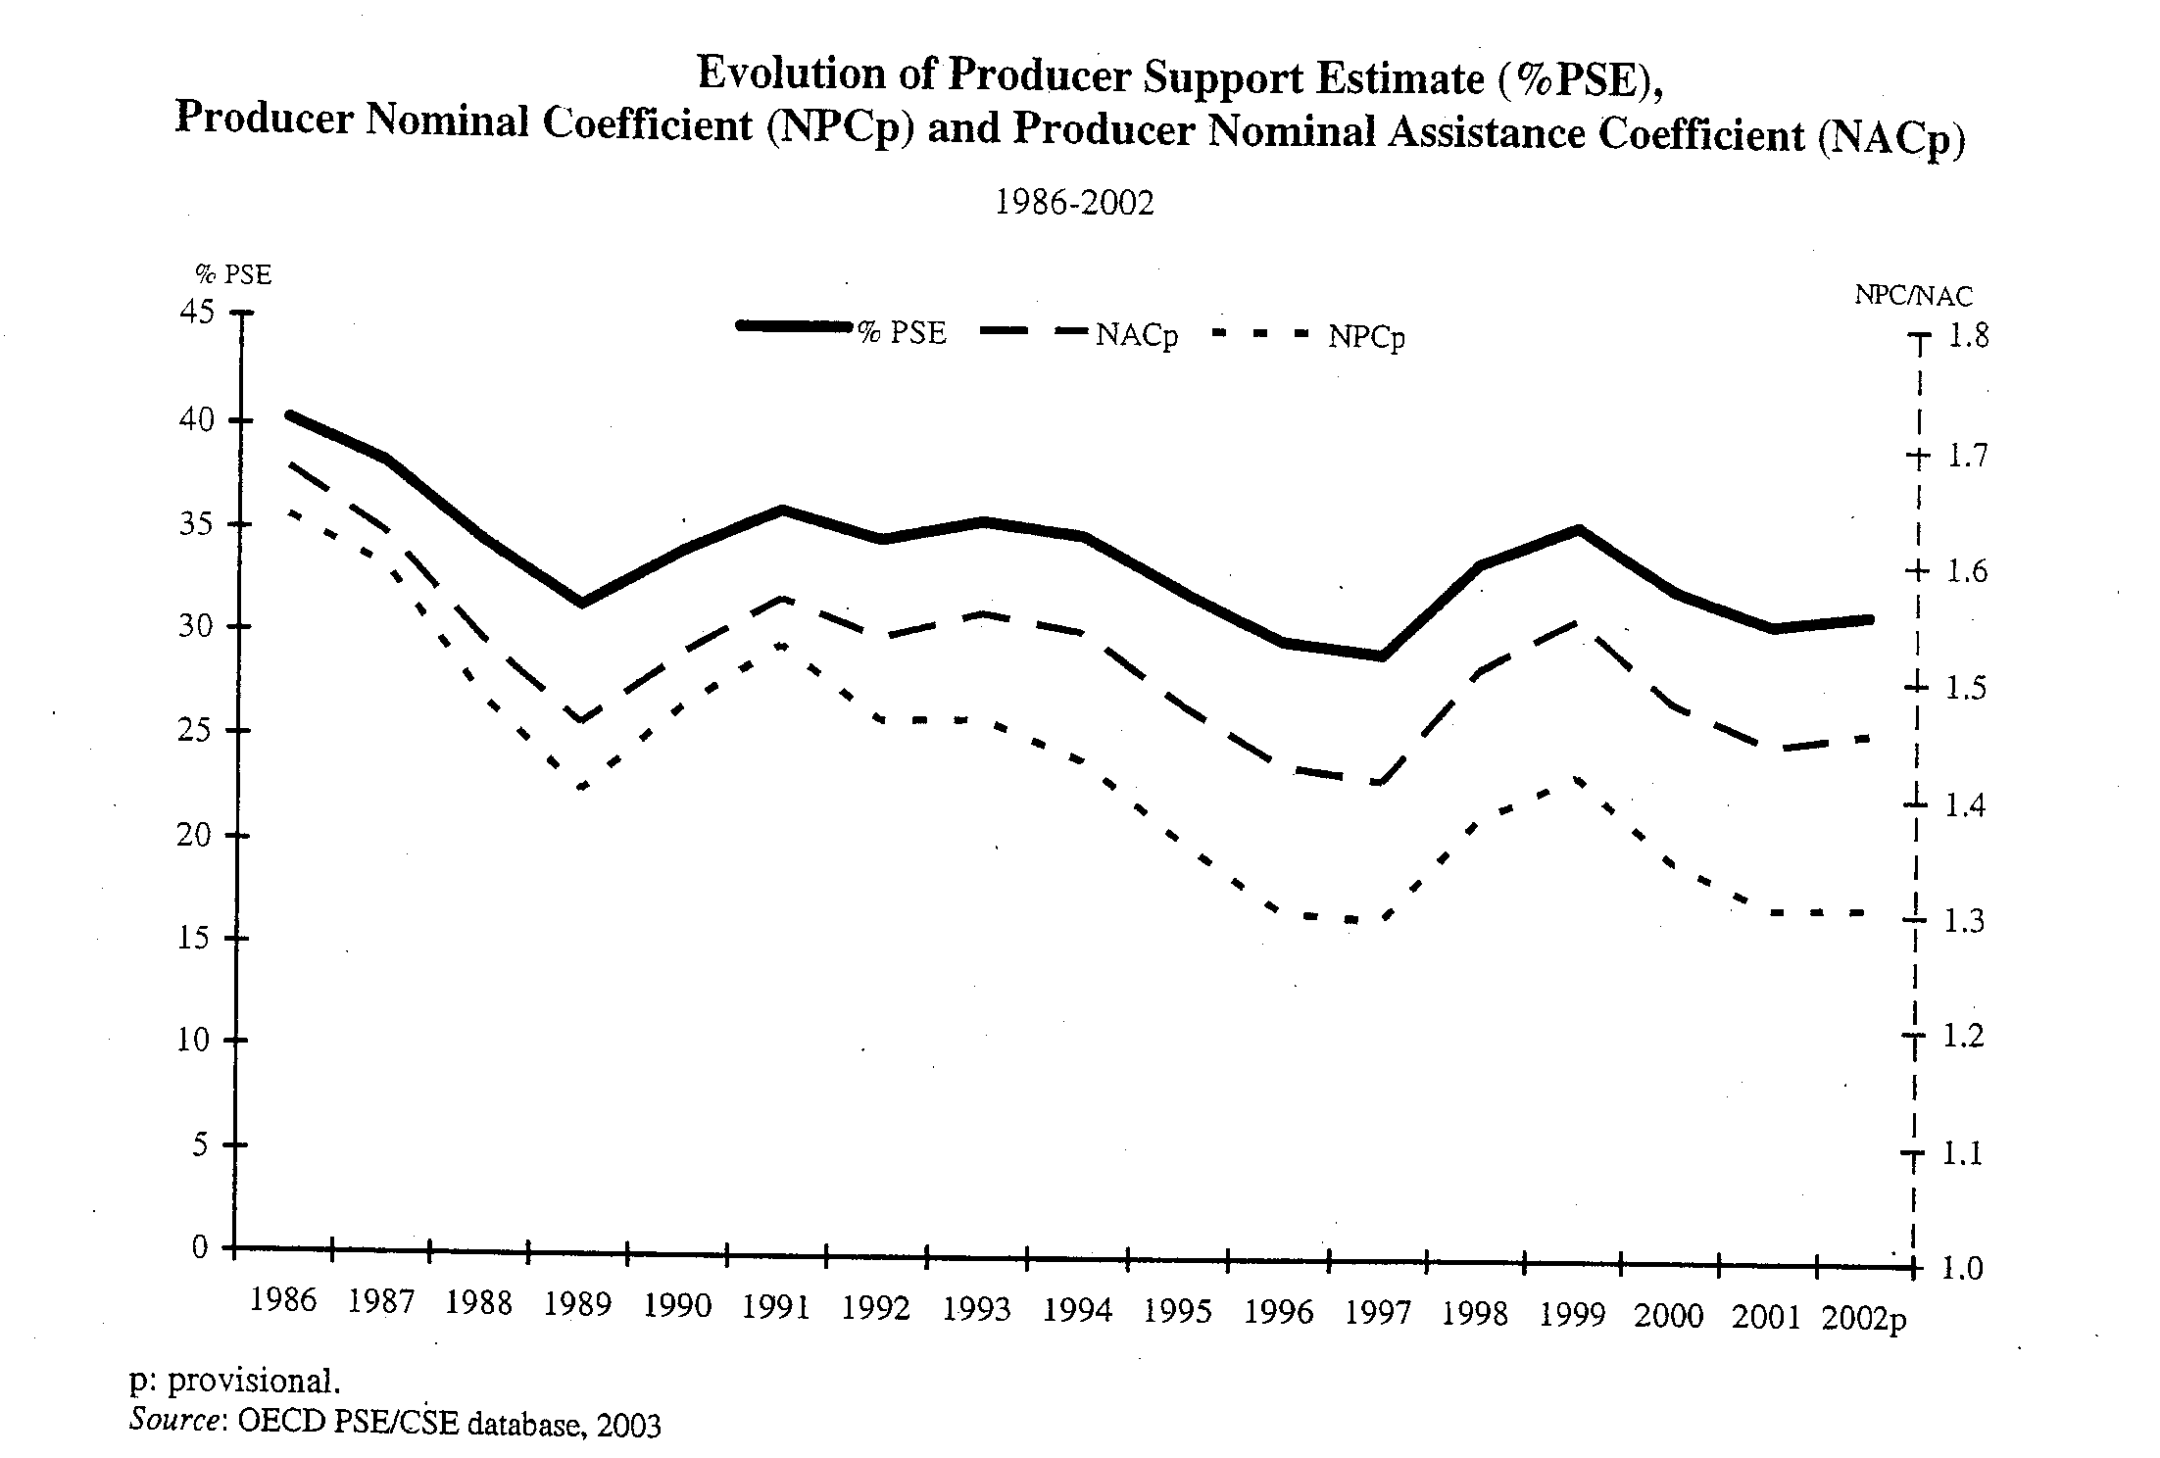
The above graph reflects the poor commitment of countries in removing/reducing their producer support programme. As from 1996 as shown by the red line the %PSE was increasing instead of decreasing.

Figure 6: Export prices

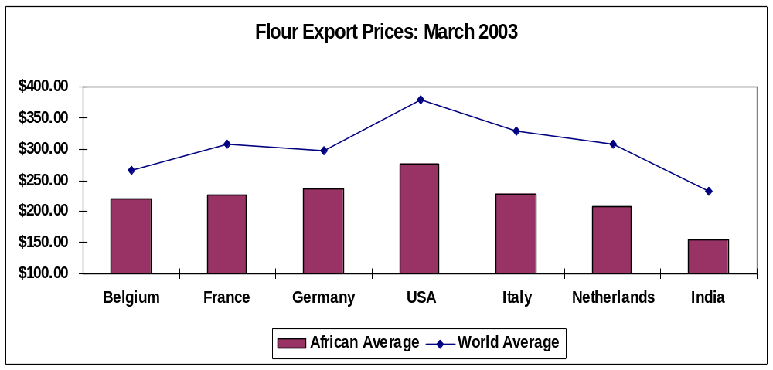
Source: Global trade Atlas

Figure 6 reflects the situation where the international export prices into Africa on average are less than the average world prices by at least 30%. This clearly reflects the situation of dumping.

The recent arrival of the food aid which has played a paternal role in supplying food to Southern African household also caused a new challenge to the wheat to bread value chain. The excess supply of food aid to our smaller neighbouring countries for example Lesotho and Swaziland enables their wheat processing industries to sell their products competitively in South Africa and maintain their commercial capacities. The over supply of food in the Southern African region also suppresses local prices. This is all to the benefit of the developed (donors) world and to the detriment to the developing world.

5. SWOT ANALYSIS OF ROLE PLAYERS OF THE VALUE CHAIN

5.1 Wheat producers

5.1.1 Strengths

- Production knowledge acquired over many years.
- Well supported by a strong producers’ organisation.
- Sound cultivar base for production.
- Important contributor to the economy of the rural areas.
- Important contributor to total agricultural GDP.
- Competitive research institute (Agricultural Research Council).

5.1.2 Weakness

- High input costs.
- High input cost/land value ratio as a result of sharp increases in variable costs of production resulting in greater production risks.
- Slow and inadequate input/product price adjustment to external factors e.g. sluggish input price downward adjustment to exchange rate strength.
- Expensive crop insurance and limited insurance capacity.
- High interest rates.
- Research results not transferred and adopted by all producers.
- Slow adoption of hedging mechanisms to reduce price risks.
- Climatic variability resulting in variable production patterns (especially summer rainfall area).
- Direct exposure to international market and exchange rate variations resulting in producer being a price taker.
- Limited number of new entrants from developing sector.
- Inadequate extension services.

5.1.3 Opportunities

- Increase supply to satisfy local/regional demand and possibly satisfy niche export market.
- Stimulate support infrastructure in rural areas.
- Increase employment in rural areas.
- More vertical integration.
- Incorporate developing commercial farmers to expand capacity.
- Significant productive capacity available.
- Durum wheat production.
- Improvement of productivity on all levels e.g. yield and quality.

5.1.4 Threats

- Subsidised imports/dumping.
- Negative impact of land taxes and other legislation threats on sustainability.
- Slow administrative process to adjust tariffs.
- Loss of research capacity at research centres.
- Deterioration of rail network servicing silos.
- High transport costs resulting in low farm gate prices (especially in Western Cape).
- Non tariff barriers affect South African wheat exports negatively..
- Over regulation of quality standards.

5.2 Infrastructure suppliers

5.2.1 Strengths

- Well organised industry association.
- Uniform grading rules are applied.
- Established training standards.
- Sound infrastructure.
- Fair competition between storage providers.
- Sound service history.
- Value added products.
- Sound administrative system to the benefit of consumers.

5.2.2 Weakness

- High maintenance cost.
- Insufficient number of silo bins for different wheat categories at silo complexes.
- Low capacity utilisation in some areas.
- Loss of skilled personnel.
- Quality and quantity risks.
- Income dependent on throughput.
- Rates are fixed for a season.
- Varying crop size determines throughput.

5.2.3 Opportunities

- Emerging sector.
- Increasing value added services.
- Increasing value added products.

5.2.4 Threats

- HIV/Aids.
- High operational costs (labour and statutory costs) / Tariffs under pressure.
- Direct wheat imports to mills.
- Direct deliveries of domestic wheat to mills.
- Decline in local production.
- Effect of international prices on local production.
- On farm storage facilities.
- Direct deliveries to mills.
- Inadequate and unreliable Spoornet infrastructure.
- Limited port capacity.
- Land Bank Act.
- Unfounded accusations of unfair practices.

5.3 Traders

5.3.1 Strengths
- Efficient and effective price discovery mechanism - Safex.
- Good local storage facilities.
- Relatively good transport infrastructure.
- Respected legal system.
- Sound financial system.

5.3.2 Weakness
- Lack of transparency and inefficiency in implementation of the tariff system.
- Poor service by Spoornet.
- Restrictive National Department of Agriculture’s Phyto-sanitary polices for wheat imports.

5.3.3 Opportunities
- Increase acceptance of a wider variety of international wheat in the local market.
- Increasing the role of Safex as a fair indicator of local wheat prices relative to the international market.
- Increasing the number of participants in the industry adding liquidity and improving competition.

5.3.4 Threats
- Intervention by government.
- Reduction in local production due to increasing production costs.
- Monopolistic practices by larger role players

5.4 Millers

5.4.1 Strengths

- Well organized industry associations.
- Sound infrastructure and training standards.
- Developed telecommunication network.
  - Well-developed transport infrastructure:
    - Roads
    - Rail
    - Port
  - Established industry base.
  - Availability of labour force.
  - Environmental awareness.
  - Strong Export committee.
  - Highly skilled professionals and institutions for research.
  - Preferred local wheat.

5.4.2 Weakness

- Inadequate protection against unfair competition.
- High input costs.
- Low level of financial commitment for research and development.
- Lack of maintenance of infrastructures:
      - Road
      - Rail
      - Ports
- Lack of access to international information.
- High delivery costs.
- High interest rates.
- Lack of innovation for new products.
- Low export orientation.
- High cost producer.
- Slow Government reaction time to trade remedies and tariff issues.
- Highly distorted international market.

5.4.3 Opportunities

- Beneficiation of raw materials.
- Available production capacity.
- Domestic and regional demand.
- Preferential export markets (African Growth and Opportunities Act, European Union, Southern African Development Community and others).
- Alternative international supplier (International political instability).
- Shift in consumer demand to organic food.
- Shift in consumer demand from maize meal to bread.

5.4.4 Threats

- HIV/Aids.
- Abolishment of protective barriers.
- Unfair competition from cheap subsidized imports.
- Non-tariff barriers by SACU and SADC members.
- Changes in regional dynamics and multilateral arrangements.
- Changes in consumer preferences.
- Food Aid donations.
- Lack of customised incentives.
- Poor domestic market economic conditions.
- Traditional brand names aligned with Codex.

  - Bakers

5.5.1 Strengths

- Stable market particularly for bread
- Market growth particularly for confectionery products
- A diversified product market with a wide range of baked products that can be marketed
- Strong domestic market
- Use of first world baking technology, processes and equipment
- A strong professional supplier network
- A strong core of dynamic entrepreneurs and baking specialists
- Valuable international contacts
- A workforce that is closely aligned to the population diversity of South Africa

5.5.2 Weaknesses

- Lack of price stability in the market and damaging price wars
- Uninformed and inexperienced entrants into the Baking Industry
- Patchy quality control
- Non-compliance with bread mass regulations
- Overall poor legislative control
- Too few succession plans to replace qualified baking personnel
- Limited commitment to training and BEE/WE
- Inadequate finance and inappropriate financial controls hampering development and growth of small/BEE entrepreneurs

5.5.3 Opportunities

- Growth potential for bread as household incomes improve
- Market opportunities for a wide range of value added baked products
- Promotional opportunities as a result of the introduction of fortified bread
- Opportunities for bakers and baking stakeholders in Africa and other overseas markets
- Opportunities for various baking training initiatives
- Opportunities for the introduction of improved information systems, market and Industry promotion
- The development of personnel within the Industry
- Development of HACCP systems for the Industry
- Development of products with health enhancing properties
- Development of financing packages tailored to the needs of small entrepreneurs/BEE entrants to the Industry
- Development and implementation of appropriate legislative systems

5.5.4 Threats

- Market saturation and runaway competition
- Imported baked products (Biscuits)
- Health “scare stories” related to baked products
- Unavailability of suitable trained personnel
- High cost of inputs
- Inappropriate and restrictive legislation

6. PROPOSED STRATEGY FOR WHEAT TO BREAD VALUE CHAIN

6.1 Vision

“To create within a free market environment, a wheat to bread value chain that meets the needs of the domestic market effectively and efficiently and is also competitive internationally, through the members of the value chain working together to develop synergies in partnership with government which will ensure the long term growth and prosperity of the wheat industry.

The industry recognises the necessity of developing appropriate strategies which will:

- Enable long-term growth and create economic wealth and job opportunities.
- Be of benefit to as many stakeholders as possible both locally and regionally.
- Be of benefit to the government as a significant stakeholder in the industry and contribute towards government achieving its goals.
- Ensure opportunities for black economic empowerment.
- Improve market access for PDI’s.

6.2 Mission

“To become a long term preferred supplier of wheat, wheat flour and wheat based products on the domestic market and in selected international markets which necessitates the industry to become driven by the needs and characteristics of its target markets.”

To achieve this mission, the industry needs and increasing awareness of the necessity to be successful locally through being able to face the competition from foreign exporters and other substitutes in familiar environment. It also needs to be able to address export markets, especially on a highly selective basis, recognizing that niche opportunities overseas can be profitable to the industry as a whole. The industry needs to appreciate the success that can be achieved by its ability to understand and respond to the markets which it is targeting. It must also recognise the need to be able to provide wheat, flour and wheat products at prices and at levels of quality determined by the market place. This must be with the understanding that subsidies and domestic supports enjoyed by developed countries will be abolished in accordance with the World Trade Organisation rules.

It is important that the industry and government agree on the appropriate interim tariffs until such time that the WTO agreements on subsidies lead to fair market related prices and a level playing field on which South Africa can compete.

Implicit in both the vision and the mission statements is an awareness that the industry’s decisions need to involve and benefit all stakeholders including government.

The objectives related to the industry goals are identified and discussed under paragraph 6.3. In each case, a justification is offered as well as an explanation in terms of how they should be addressed. The industry has done considerable work to support some of the objectives. The proposed strategy starts by looking at the industry trends from the global and local perspective.

6.3 Objectives to achieve industry goals

After extensive analysis and ongoing discussions between all role players, a number of objectives were identified. These objectives are seen as being a gateway to achieve success for the wheat value chain and match the vision and mission statements of the industry.

6.3.1 Co-operate with government and government agencies and obtain their active support to achieve short and long term industry goals

This objective points to the importance of government and industry partnership in growing the industry to the benefit of the country as a whole. In achieving this, the following issues need to be addressed:

6.3.1.1 Trade and Tariffs

(a) Fair competition with respect to international markets.
(b) Introduction of clear policies that protect the agricultural sector against unfair trade agreements, trade policies and international subsidies.
(c) Government to revise its decision regarding wheat flour import duties (HS1101). The current dispensation is in contrast with the developed world’s intentions not to remove international subsidies.
(d) Government to cancel the rebate facility for wheat in the BLNS countries.
(e) Government to speed up the administrative process of the tariff adjustment system.
(f) Government to assist in funding a study on the effect of international subsidies on the domestic wheat industry.
(g) Government to ensure that international food aid to other countries does not impact negatively on commercial business.
(h) Government to ensure that South Africa’s donated food aid to other countries is in processed form and not as raw material.
(i) Government to facilitate access for South Africa to international food aid and food supply tenders in our region. Non-Africa countries or developed countries should not be allowed to participate with subsidised products.
(j) Government to promulgate safeguard measures to be used.
(k) Improvement of proper control for illegal imports i.e. rules of origin and sanitary and Phyto-sanitary measures.
(l) Government to continue involving the industry for support and advice on issues that relate to bilateral and multilateral trade agreement negotiations.

6.3.1.2 Quality and Standards

      - Establishment of a single National Food Control Agency.
(b) Local standards must be maintained and policed.
(c) Government to enforce the quality standards at ports and border posts.
(d) Government to give incentives/assistance to the industry for adding extra substances in their final products for health improvement. (Fortification process).
(e) Industry to create generic minimum standards through the HACCP (Hazard analysis and identification of critical control points) system to enhance food safety.

6.3.1.3 Information

- Familiarising government officials on how the different sub-sectors within the wheat value chain operate.
(b) National Department of Agriculture to maintain core statistics such as crop estimates.
(c) Government to be transparent when dealing with issues that have a direct impact on the industry.
(d) Government to assist in distribution of information.
(e) Make imported wheat quality results available to the industry.
(f) Consumer Price Index basket should be reviewed to contain relevant products.
(g) Negotiate with government to computerise strategic information (e.g. export and import permits, quantities issued and realised, customs and excise information, etc) and make it available to industry free of charge and timeously.
(h) Development of Information Reference System (IRS) and an Information Help Desk (IHD).See Annexure D for objectives
(i) Development of market information data base to assist with future planning.

6.3.1.4 Research

(a) Government to maintain and increase research capacity.
(b) Increase government contribution to research.
(c) Improve technology transfer systems.
(d) Needs driven research in partnership with industry.

6.3.1.5 Infrastructure

- Government to maintain and upgrade existing road and rail infrastructure.
- Spoornet should not be making profits from the transport of wheat and flour, as this affects the South African food security position.
- Spoornet to maintain existing rural lines to facilitate market access.
- Spoornet must obtain and spend capital to upgrade the grain fleet and support services.
- Capital recovery out of increased rail tariffs to be fully transparent and recovered over a long term.
- Government to encourage maximum use of port silo infrastructure at East London to spread the load carried by Durban port.
- Government and industry to encourage rail friendly grain to alleviate the problems on the roads.
- Spoornet should take their social responsibility as a national carrier (rail monopoly) into account when developing policies.
- Spoornet to ensure fair rates and rate increases in line with government fiscal policy and the effect of administered prices on inflation and the cost of basic foodstuffs.

6.3.1.6 General government issues

(a) Government to be involved and to participate in the creation of the support system for the emerging sector.
(b) Ensure that countries exporting to South Africa comply with International Labour Organisation core labour rights.
(c) Government to provide finance, as for other industries, for upgrading plant and machinery at below prime rate.
- Industry to be granted special water and electricity rates.
(e) Government support in terms of cash grants and other forms of incentives for the development of world class technology and information systems.
(f) Government should give preference to locally produce products in the composition of food parcels in the feeding schemes.

6.3.2 The entire value chain must put in place methods of best practice and set standards against which they can constantly be measured

This objective recognises that to be world class, there is a real need to be generally more efficient in all aspects of business. It is also true that improvements in performance by all players of the value chain must necessarily be addressed.

The issues highlighted below will assist in achieving the above set objective.

6.3.2.1 Training

- Involve the relevant Sector Education and Training Qualifications Authority in the development of appropriate sector skills plans that will contribute towards the development and learning of employees within the industry.
- Training to develop core competencies required to meet competition:

  - Product Innovation
  - Multi-skilling competencies
  - Marketing

        - Training of previously disadvantaged individuals to become specialists at all levels in the industry to be investigated
        - Identify relevant skills development topics for management and extend it to previously disadvantaged individuals.
        - Continue training and employment registered in terms of the new national legislation. Annexure 3.
        - Engage with the Department of Labour and labour movements on policies that will improve the competitive position of the industry

6.3.2.2 Technology

Success will depend upon local stakeholders making use of world class technology at manufacturing level and in the area of information systems. This requires investment in financial terms as well as in human skills. Government support in terms of cash grants or other forms of incentives must be sourced.

      - Government Policies

(a) Industry needs information on new government policies.
(b) Existing policies need to be continually evaluated and amended where necessary.

6.3.3 Identify international marketing opportunities and monitor and analyse the trade agreements to the benefit of the industry

This objective recognises the need for the industry to be involved in export. Individually, manufacturers do not have the resources to succeed alone in the international market. The formulation of an Export Council is important to assist and manage the export drive on behalf of those manufacturers. The South African milling industry is a major player in the Southern African region. However certain trade issues like rebate systems and non-tariff barriers by the member countries (South African Customs Union and the Southern African Development Community) impact negatively on industry exports. The industry has taken a leading role in trying to initiate the removal of these barriers as way of making their export drive more efficient and effective – Annexure 2.

The South African wheat industry has also aligned its goals to that of the government NEPAD (New Partnership for Africa's Development) initiative by investing in other African countries for improvement of those economies and improvement of South African industry regionally. The Agricultural Research Council could play a major role in promoting wheat production in SADC. These achievements or investments reflect the industry commitment to become more competitive as a global player. The industry is also working with government in the negotiations on free trade agreements that have being earmarked so as to strengthen their position both locally and internationally. The industry continues to play a vital role in the international arena in terms of its input to make the agricultural sector more competitive in line with the World Trade Organisation Agreement for trade liberalisation.

In achieving the above objectives the following issues need to be addressed:

- Formation of Joint Action Group
- Access to an international data base.
- Capacity (Skills pool) to deal with export and import barriers.
- Implementing World Trade Organisation tools to position the industry competitively internationally.
- Economic research to influence tariff policies.
- Formulation of a clear policy regarding international subsidies, unfair trade agreements and tariff issues.

6.3.4 Assist in the development and participation of Black Economic Empowerment (BEE’s), Small, Medium and Micro Enterprises (SMME’s) and Women Owned Enterprises (WE) within the industry

The industry recognises and acknowledges the importance of assisting BEE, SMME and WE groups as one of the key government objectives. The industry has done lot of work in this regard, but much can still be done to afford the BEE’s, SMME’s and WE’s the opportunity of becoming competitive and significant players within the industry. Where businesses are owned by previously disadvantaged persons, the industry has the responsibility to assist them in their pursuance of business. In achieving this objective, the industry will focus on the following issues:

        - Outsourcing some opportunities to the BEE’s, SMME’s and WE’s.
        - Provide technical and management assistance.
        - Convince government to give financial and technological assistance to the BEE’s, SMME’s and WE’s.
        - Provide necessary training.
        - Assist in procurement of input raw materials.
        - Assist in logistical support and marketing of their products.

The issue of equity should be read in conjunction with LRAD (Land Redistribution and Agricultural development)

This recognises the importance of an industry-driven consolidation through sharing of expertise for the mutual benefit of stakeholders of the industry. It also recognises government’s policy of assisting developing players and the need to nurture them.

    - Other industry initiatives to assist Previously Disadvantage Individuals

        - Winter Cereal trust to commission a study to determine the needs of PDI’s within the wheat industry.
        - Implementable actions to be carried out after the study.
        - Winter Cereal Trust to fund bursaries for students in research and leadership or management programmes.
        - Encourage and motivate students to do agricultural courses.
        - Form partnership with industry employers for bursaries and mentorship.
        - Score – card to be drawn up for minimum market access.
        - Support services e.g.. Study group, technology transfer, internship, extension services, etc.
        - Make SAGIS and SAGL information more accessible.
        - Encourage equity employment within SAGIS and SAGL.
        - Assist industry PDI’s to become involved in SA and International Forums.

6.4 Industry programmes

ACTION | PRIORITY  A, B, C | WHO? | TIME FRAME | DRIVER
Strategy Presentation | A | Wheat Forum/DTI | Phase1: Complete-12/03  Phase2:  Workshop-23/01/04  Phase3:  DTI-02/04  Phase4  Minister | PJ  Leon  Dr. Brock
Wheat flour tariff | A | WF/DTI/ITAC | Ongoing | Jannie & NH
Trade Issues  - Unfair Trade Agreements  - Policies  - Subsidies  - Trade Negotiations | A | WF/DTI/ITAC | Ongoing | Jannie & NH
Rebate Facility | A | WF/DTI/ITAC | Ongoing | Jannie & NH
Tariff Adjustment Sys. | A | WF/ITAC/SARS | Ongoing | Jannie & NH
Study on Effects of Subsidies | A | WF/TIPS/DTI | 05/04 | Jannie
International Food Aid  - Impact  - Form | B | WF/NDA/WFP/ TIPS | 03/04
Safe Guard Measures | A | WF/DTI/ITAC | Phase4:  Minister | Wish List
Control of Illegal Imports | A | WF/NDA/SARS | Wish List | Jannie & NH
National Food Control Agency | B | NDA/DOH | 06/04 | NH
Quality Standards  - Ports and Border Posts  - Domestic Control | A | WF/NDA/DOH/ SARS |  | NH  & Dirk
Fortification Incentives  Monitoring | A  A | WF/DOH/DTI/DOF  WF/DOH/DTI | 12/03  Ongoing | PJ  Peter C
Field Trip | A | WF/ALL STAKEHOLDERS | Ongoing | NH

Government Consultation | B | WF/NDA/NAMC | Ongoing | Wish List
Analytical Information | B | WCT/SAGIS/NDA/PDA | Ongoing Wish List | NH & Dirk
Research and Development | A | WF/NDA/NARF/ARC/WCT/PDA’S/DACST | Ongoing | Leon &  Jannie
Strategies to Support Emerging Farmers | A | WF/WCT/CONSULTANTS/NDA | 05/04 | Leon & NW
Compliance of ILO Regulations | B | WF/DOL/ILO/SARS/NDA | Ongoing | PJ &  Setimela
Incentives | B | WF/NDA/DTI/Landbank/DOF/Local Authority/Eskom | 10/04 | PJ
Extension Services | A | WF/PDA’S/NDA | 10/04 | NW
Road and Infrastructure Development | A | WF/PDT/SPOORNET/TRADE ENVIROMENTAL COMMITTIES/PORTS AUTHORITY | Ongoing | John G.
TRAINING  Farm level  Traders  Silo  Milling  baking | A  A  A  A  A | SECTOR STARTEGY  GSI/SETASA/DOL  NCM/SETASA/DOL  NCB/FoodBev SETA/DOL | 05/04/Ongoing  Ongoing  Ongoing  Ongoing  Ongoing | NH  John G.  Dirk  Jannie  Peter
HIV/AIDS Policies | A | WF/FAWU/DOH | 05/04 | Setimela
Exports Barriers/Promotion | A | EC/DTI/NDA | Ongoing | PJ
Trade Agreements | A | WF/DTI/ATF | Ongoing | Jannie & NH
International Trade Database | A | NCM/NDA/TIPS | 05/04 | Jannie
Information Update on the Wheat Flour Tariff Document | A | WF/NDA/ITAC | 03/04 | Dr. Brock
Transformation Plan | A | WF | 30/01/04 | Steering committee Dr. Brock

7 Conclusion

In conclusion the industry would like to reiterate its commitment to the transformation of the whole value chain, so as to reflect the modern industry in new democratic South Africa. The industry is looking forward in becoming a global player through the Free Trade Agreements negotiated by government with the business advice from the South African industries at large.

The industry commits itself to be pro-active in its dealings and also to take into consideration the overall objectives and goals of government. This strategy also reflects industry commitment to partner with government in ensuring a prosperous and economically viable industry that benefit all stakeholders. All the role players within the Wheat to Bread value chain commit themselves to the four major objectives they have set out to achieve (see page 3).

It is on these commitments that the industry calls on government to assist it in attaining its objectives by protecting it against unfair competition from developed countries especially in terms of their subsidised products and food aid donations which are eroding our markets.

- ANNEXURES

8.1 ANNEXURE A: LITERATURE REVIEW OF PREVIOUS INVESTIGATIONS THAT IMPACTED ON, OR REFERRED TO, THE WHEAT TO BREAD VALUE CHAIN.

Over time, several studies and investigations were commissioned to evaluate the Marketing Act of 1968 and the marketing schemes in general, as well as the wheat industry in particular. Although there were earlier reports, the 1976 Wentzel Commission Report, following an investigation into the Marketing Act, is used as a point of departure for this purpose. This was followed by numerous other reports of which the major relevant findings are listed.
1. The Commission of Enquiry into the Marketing Act (The Wentzel Commission) – 1976
This Select Committee was appointed by Parliament and later changed to a Commission of Enquiry to report and make recommendations regarding the structure of controlled marketing with specific emphasis on how the NMC was constituted and its powers and functions; how controlled marketing had evolved over time; aspects of the application of the marketing schemes and the functions of the control boards.
In general this Commission found that there was need for some degree of state control over the marketing of agricultural products. They further felt that the control board system had been systematically developed and that it was making an important contribution towards the healthy and balanced development of agriculture. Several recommendations were made, some of which (in their opinion) required immediate attention. One such recommendation was the “modification of the process of price formation”. In reference to the Winter Cereals Scheme and wheat industry, they made the following recommendations (which were all implemented over time):
- The control of imports and exports of agricultural products should rest with the Government in the first instance and the Minister must decide on overall quantities for import and export;
- The Wheat Board must retain the power to register mills and to refuse such registrations;
- The system of restrictive registration by the Wheat Board be replaced by formal registration in the case of confectioners;
- The system of restrictive registration by the Wheat Board be retained in respect of bread bakers;
- The subsidising of the bread price should be systematically reduced;
- The Act should be amended to afford the Minister the power to fix prices and margins following recommendation by the Boards and in consultation with the NMC.

2. The Working Committee re the economic position of the farmer and agricultural financing in general (Jacobs Committee) – 1978
This Committee was appointed with the following terms of reference: to investigate, report and make recommendations regarding the economic position of the farmer and agricultural financing in general. Special reference was to be made to the ever increasing production costs, increasing debt position of farmers, capital returns, the extent to which existing finance sources fulfil the farmers’ needs for short, medium and long term credit and the role of agricultural co-operatives in supplying credit to farmers.
The recommendations by this Committee of relevance to this report are:
- They agreed with the principle that actual costs of production and current producer prices should determine production patterns, but were not in favour of subsidies to agricultural producers in order to counter increasing production costs;
- They were of the opinion that the agricultural sector should not only be able to feed the rapidly growing population of SA, but should also produce for the export market;
- They indicated that there are valid reasons to rethink measures to enhance the financial position of farmers in order to restore agriculture on a sound and viable basis;
- They further recommended that the strategic importance of agriculture in reaching especially the objective of self-sufficiency should receive greater prominence and that Government’s objectives in this regard must be clearly stated.

3. The Interdepartmental Committee regarding the establishment of bakeries (Brand Committee) – 1978
This Committee was tasked to investigate and report on the implications for the SA Government in the establishment of bakeries and delivery of bread in certain self governing and independent states in Southern Africa. The principles contained in the existing customs union agreements had to be borne in mind in the study.
They made several recommendations of which the relevant ones are (these were subsequently applied):
- When considering the location of a bakery and delivery of bread in or near the self governing or independent states, their balanced economic development must be a priority. This should be done bearing in mind that current bakery interests should not be negatively affected, while the utilisation of scarce capital to duplicate production capacity should also be guarded against.
- The Wheat Board must stick to its declared policy that it will not allow the establishment of new bakeries or the expansion of existing bakeries in “white” areas which are aimed at the bread market in the “self governing” or “independent states”;
- The Government should enter into discussions with “self governing” and “independent states” regarding the establishment of bakeries and delivery of bread. The Governments of the “self governing” and “independent states” should be made aware of the prescriptions in terms of the customs union agreements and the consequences if they do not adhere to the prescriptions.

4. The BEPA Report regarding the costs, advantages and financing of protection in SA – 1983
The Bureau for Economic Policy and Analysis undertook an investigation into the cost of secondary industry protection in the course of 1982. Following this study, many questions were asked regarding the cost effects of control in the agricultural sector and this eventually led to the study being expanded to include agriculture. In the agricultural investigation, the issue was not the extent of protection but who actually pays for this and if it is fair. Although the lions share of the report was allocated to the position in the maize industry, other commodities were also looked at and compared.
The Committee found that local production costs increased at an exceptionally high rate between 1970 and 1983. Only a part of this increase could be ascribed to protection of enterprises that supply inputs to agriculture. The major part was as a result of inflation in SA. This was not corrected by the effective exchange rate in all the industries. A shift in comparative advantages in favour of the mining industry and at the expense of other industries was also primarily to blame for the predicament agriculture found itself in. To keep farmers farming under these circumstances, producer prices were fixed to match local production costs. The output side was thus far more protected than the input side of agriculture. The enterprises that basically serviced the domestic market could be artificially carried by this policy. The export-orientated industries could not and the possibility of subsidies arose.
In conclusion, BEPA found that, while the cost of protection for agriculture could be ascribed to government measures, the decline in comparative advantages compared to especially the mining sector as well as the evolution of overseas prices represented elements of structural changes for which the SA Government could not be held responsible.

5. The Commission of Investigation into the Government Subsidy on Bread (Davin Commission) – 1985
This Commission was appointed to investigate the justification and continuation of the bread subsidy. They were specifically asked to pay attention to the extent of the subsidies, sources of finance and the application of the subsidy to maximise the advantages thereof for underprivileged consumers. The members of the Commission were not unanimous in all of their recommendations. They did, however, agree that the Wheat Board should continue fixing producer prices. Although the recommendation was made that price control on flour and standard bread and restrictive registration of millers and standard bread bakers must be removed immediately, the minority view was that this should be phased out over time. This was to happen eventually, but based on another investigation following a cabinet decision.
6. The Competition Board investigation into the milling and baking industry – 1985
The Minister of Trade and Industry tasked the Competition Board to investigate all aspects of economic competition in the milling and baking industries.
This report outlined the historical developments in the milling and baking industry, especially the appearance of the Wheat Board in 1935 together with the different Wheat and Winter Cereal Schemes, which were put in place over time. The second chapter was devoted to the situation in the industry at the time of writing the report, i.e. the primary and secondary industries, the degree of concentration, consumption trends, etc.
An entire chapter was devoted to subsidies and the effect thereof on the industry as well as cross subsidising within the industry.
The Competition Board was of opinion that the bread subsidy could not be continued in its existing format. The recommendations of the Davin Commission were thus supported. They further found that the practices of market sharing, uniform prices, standards and credit conditions were not in the public interest. These practices were subsequently declared illegal in terms of the Competition Act. The milling and baking industries, however, obtained approval to continue with these practices until the bread subsidy was eventually repealed.

It was also recommended that the system of restrictive registration of millers and bakers be replaced by formal registration and that price control be repealed on millers’ and bakers’ products.
7. The National Marketing Council Investigation into the operation of the Winter Cereal Scheme – 1986
As part of a request by the Minister of Agriculture to investigate the application of the different schemes, the NMC also investigated the Winter Cereal Scheme. Some of the aspects that had to be looked into included whether the existing scheme and prohibitions should be continued, the justification for the continuation of the scheme, the possibility of merging with the administrations of other schemes and the justification for the continuation of all measures in terms of the scheme.
In short, the NAMC recommended the following (all subsequently implemented):
- The Winter Cereal Scheme should be suitably amended to do away with restrictive registration of millers in favour of formal registration;
- The Winter Cereal Scheme should be suitably amended to make provision that all manufacturers of wheat products who do not produce standard classes of bread only have to register formally (not restrictive registration);
- The Wheat Board should continue its policy of restrictive registration of bakers who produce standard classes of bread. Should the bread subsidy, however, be repealed, this should be revisited.
- The Wheat Board must continue its lenient policy with regard to bakeries producing standard bread in “non-white” areas.

8. Investigation into control over and support to the wheat and wheat processing enterprises abroad: a comparitive study by Prof IJ Lambrechts, Mr NF Alberts, Mr JF de Villiers and Mr LH van Staden – 1989
The report started by referring to previous studies done in the industry and the outcome of these. An explanation was also given of the countries visited and how this was decided on. In essence the authors looked at control and support in the wheat and wheat processing industries in a number of countries – some of which were visited and some others for which information was obtained.

One of the findings of the report was that South Africa can not be directly compared to any of the countries visited. This is because of differences with regard to aspects such as degree of urbanisation, inflation rate, per capita income, the degree of vertical integration, prices, subsidies, etc.

What was clear to the authors was that South Africa’s single channel marketing system was not in line with developments in the rest of the world. All the countries visited had different systems in place with regard to aspects such as strategic stocks, subsidies and financial support to producers and processors of wheat.

A number of aspects were highlighted with regard to countries where control had been abolished. These included new entrants to the market, the prices of the different products, quality and vertical integration.

The final recommendation in the report was that a comprehensive investigation of the wheat value chain needed to be done before the Government finalised its decisions regarding the deregulation of the wheat industry in South Africa.

9. Report of the Committee of investigation into phasing out the Bread Subsidy (Blignaut Report) – 1990
During 1988, Cabinet decided in principle to phase out the bread subsidy gradually over three years. A Committee was appointed to formulate a strategy for phasing out the bread subsidy scheme and to make recommendations to Government with regard to the adjustments required in respect of those regulations applicable to the baking and milling industries which would be affected by the withdrawal of the subsidy as from 1 March 1991.
This entailed the termination of:
- the bread subsidy;
- price control on flour and standard bread;
- restrictive registration of standard bread bakers; and
- the market sharing arrangements operated by the baking industry in terms of an exemption under the Competition Act.

10. Reports by the BTT into the price mechanism in the food chain with recommendations for its improvement. – 1992
The BTT was asked to investigate the increasing gap between producer and consumer prices, and food price increases. The wheat chain was one of the food chains chosen for special investigation. In their preliminary report, the following general recommendations were made:
- The BTT believed that increasing food prices were a symptom of an inflationary spiral which could only be broken by ensuring that adequate competition existed throughout the chain;
- To do this, deregulation had to be applied on a broad front; greater competition from abroad fostered and statutory intervention terminated.

The final report found that there was a price divergence of five percentage points per year over the period 1980 to 1991 between the farmer and consumer food prices. This 5% could be broken down as follows:
Input cost inflation 3,0%
Declining productivity 1,0%
Price and supply stabilisation 0,5%
Withdrawal of state subsidies 0,3%
Lifting of price controls 0,2%
The sharp increase in food inflation in the post 1991 period was mainly due to the introduction of VAT.
The BTT could not identify a single cause over the long term for the price divergence in the food chain. They confirmed that they were of the opinion that increasing food prices were a symptom of an inflationary spiral, which could only be broken by ensuring that adequate competition existed throughout the chain, and that deregulation should be applied on a broad front. A major deviation from the first report was, however, their changed opinion that the control board system should not be terminated but that it should be made more efficient and that the different controls should be re-evaluated.
11. The Report of the Committee of Inquiry into the Marketing Act (Kassier Report) – 1992
This Committee was appointed by the Minister of Agriculture to conduct an in- depth inquiry into and report on the marketing of agricultural products under the abbreviated heading “Marketing Act 59 of 1968 quo vadis”.
The Committee indicated that they believed that the winter grain marketing scheme was not serving the best interest of a large number of producers, millers, processors, bakers and consumers. The basic objectives of the scheme, namely to stabilise the industry to enable efficient production, to reduce marketing margins and to preserve the natural resource base had also not been achieved. They indicated that they took note of the deregulation, which had taken place in the industry, but were of the opinion that the manner in which it was done left much to be desired. Deregulation in the bread industry had created monopoly positions for certain individuals and organisations without the necessary statutory controls.
Some other more general recommendations included:
- That the standards for the grading of maize, wheat and other grains be adapted to better reflect the nutritional and economic value of these commodities.
- That the grain boards, given the fact of statutory protection and powers, become more consumer friendly in their pricing policies.
- In the case where boards follow unitary pricing policies, that these be abolished immediately in favour of a pricing system, which better reflects comparative advantage, including locational and quality differentials.
- That, with proper consideration, statutory single channel and price support marketing schemes be abolished and the present boards operate as private and voluntary organisations.

12. Reports titled A framework for a future agricultural marketing policy for the RSA and the implementation thereof (Basson Committee or AMPEC) – 1994
Two reports were tabled by this Committee appointed by the Minister of Agriculture to advise on a framework for and the implementation of a future agricultural marketing policy. In the first report, guidelines for the future dispensation were suggested. A few are listed below:
- “Guideline 3
Deregulation of agricultural marketing should form part of an integrated economic liberalisation programme for the whole economy, with the objective of improving sustainable economic performance and growth through the promotion of fair competition.”
- “Guideline 6
Agricultural product prices should reflect comparative and competitive advantages derived from factors such as transport, storage and quality. Price differentials and costs relating to these factors should be devolved to the functionaries where they originate, which implies that pooling of income and costs should be limited or avoided and constantly scrutinised. Cross-subsidisation between products is highly undesirable.”
- “Guideline 8
The location, capacity and competitiveness of grain storage facilities should be dictated by the market…”
- “Guideline 20
In the application of agricultural policy, intervention must preferably take place at the exact point at which the underlying market imperfection occurs or the non-economic goal lies, and must be proportional to the degree of distortion.”
- “Guideline 23
Supply stability measures must preferably be voluntary and applied in such a way that they do not interfere with the normal competitive position of the suppliers and buyers of such products.”
In the second report, the different boards and schemes were evaluated. The comments of the Committee on the Wheat Board were as follows:

“The different approaches in the submissions received, indicate clearly that agreement is still to be reached on how the Board intends to manage the marketing of winter cereal. All interested parties, however, accept that changes will have to take place in the industry in order to assure a more market-orientated system.

According to the Wheat Board, the most significant motivations for maintaining a single channel marketing system are found in controlling a balance between the distribution of the different qualities of wheat from different production areas to the milling industry and the minimising of transport costs.

Furthermore, in certain production areas (Rûens and Swartland) wheat is a primary crop and thus forms an important economic basis in the areas with no definite alternative. Production in these areas is relatively constant but they are also normal ‘export’ areas of wheat (Western Cape). This results in that, as a result of the introduction of tariffs, transport costs cannot be simply diverted to the buyers and can possibly result in a financial disruption of certain areas in the Western Cape. Therefore, a modification to the current system can be disruptive and statutory measures are thus still considered necessary.

AMPEC agrees with the opinion expressed by the largest section of the processing industry as well as the producers that the winter cereal industry requires time to move to a market-orientated system. Although consensus could as yet not be reached about a time schedule, AMPEC is of the opinion that it should be phased in over a longer period than one year.

Problematic issues such as the fixed price system have already been identified as aspects for which urgent solutions must be found. It has already been accepted that the industry will have to apply tariffs before the beginning of the 1994/95 season, accompanied by adjustments to the current marketing systems. The ‘Wheat Forum’ was established on which interested parties in the industry are represented in order to discuss relevant subjects. The ‘Wheat Forum’ has also indicated May 1994 as its target date for the finalisation of certain aspects in view of submitting a tariff application.

AMPEC welcomes the fact that the Wheat Board and the processing industry are involved in negotiations on important issues regarding the future marketing of wheat.

AMPEC supports the proposed move to a system of pools on condition that it provides efficient comparative advantages and disadvantages.

AMPEC has taken cognisance of the specific adjustment problems experienced in the industry and the importance of the wheat industry as a provider of food and job opportunities. Concern within the wheat industry regarding the possible negative impact of the importation of low cost, heavily subsidised wheat in the strive for food security has been noted. It could possibly have an adverse effect on the production, processing and marketing of local wheat, especially in the light of the important role that the wheat industry plays in certain production areas.”

13. LAPC, Bread price control and subsidies – Jonathan Binen – January 1995

14. Business Plan of the Wheat Board - 1996
The final stage in phasing out the provisions of the 1968 Marketing Act and the schemes was the submission of business plans by all the control boards. In these documents, the boards were required to indicate how they would be phasing out their activities, dealing with the final disposal of their assets etc. The Wheat Board’s business plan was approved by the Minister of Agriculture on 2 September 1997. The following decisions were inter alia approved:

* That the existing legislation on winter cereal and winter cereal products be repealed, namely the regulation on Levies and Special Levies (31 August 1997), and Registration of certain persons (31 October 1997), but that the regulation on Records and Returns only be repealed on 31 December 1997;
* That the current functions of the Wheat Board be phased-out as planned;

* That the laboratory function be continued by the to be established SA Grain Laboratory, which has already been approved in principle by the Minister;

* That the existing information services be incorporated into the SA Grain Information Services;

* The establishment of two Trusts, namely a Winter Cereal General Trust and a Winter Cereal Research Trust.

15. Wheat, Milling and Baking Cluster Atlas - 1997
The Wheat, Milling and Baking Cluster initiative was officially launched in June 1997, after considerable consensus-building and preliminary work, with the aim of proactively preparing all stakeholders in the industry for the upcoming changes of deregulation and globalisation.

Key themes used throughout the drafting of the Atlas, were as follows:

- “The cluster has historically been characterised by a low focus on understanding of demand conditions, due to the effects of the single channel system;

16. Report 3932 – April 1999, revision of the tariff dispensation on wheat, wheat flour and product thereof. BTT Report

17. National Agricultural Marketing Council Section 7 Committee: Evaluating the deregulation process: Wheat to bread value chain – December 1999

The Minister of Agriculture requested the Marketing Council to appoint committees to evaluate the impact of deregulation which took place in 1997. A team of industry experts together with the NAMC compiled a report evaluating in detail the impact of deregulation. Various problem areas were identified and recommendations were made to rectify these problem areas.

In general the committee found the process went exceptionally well from a highly controlled market to a free market. The analysis done by the industry expert was very practical and clearly understood. It is of great concern that despite the well motivated and properly analyzed situations most of the recommendations of the committee have not been implemented. The problem area identified and recommendations made regarding those problems are still present in the value chain and is still creating some problems.

This document is a well documented document and established reference for the wheat to bread value chain.

18. Bureau of economic research: HIV/AIDS: Impact on Wheat flour and Maize meal sales – 30 March 2001

This report analyses the impact of Aids on the quantities of flour and maize meal sales in the various provinces and South Africa as a whole.

19. The strategic plan for South African Agriculture (Sector plan) – 27 November 2001

Agricultural sector plan – Agri South Africa, NAFU and the National Department of Agriculture concluded a range of negotiations and formulated a strategic plan for South African agriculture. This is an important pillar in the economic growth and strategy plan of the Government to grow the economy and to create jobs. The Wheat to bread value chain also forms an integral part of this approved sector plan.

20. Dr Ian Edwards (Australia): The South African Winter Grain Research Programme – An evaluation of the current status and future research priorities, May 2002

This report was done on the request of the Wheat Forum to evaluate whether the focus of the South African research programmes is on the right track.

21. A report to the National Treasury price behaviour in the South African food and agricultural sector by Professors Nick Vink and Johan Kirsten. June 2002

This report deals with the reasons for the huge food price increases during 2002.

22. Investigation into the small and medium sized bakeries in South Africa – Chamber of Baking and the HSRC – June 2002

This report evaluated the DTI’s programme to encourage small bakeries.

23. Competition Commission of South Africa: Final report enquiry into food price rises – October 2002

24. South African Grain Industry sector plan – November 2003

Grain sector plan –following from the agricultural section plan the department of agriculture is currently (Nov 2003) taking the need in formulation a grain sector plan based on the objectives of the agriculture sector plan. This process is reaching its concluding consultation period and would probably be finalise early in 2004.

8.2 ANNEXURE B: INDUSTRY COMMUNICATIONS WITH GOVERNMENT:

APPLICATION | DATE APPLIED | BTT REPORT COMPLETE | GAZETTED
Report 3932 Wheat and Flour Tariffs | 27 November 1997 | 17 February 1999 | 14 April 1999
Report 3976 Maize and Maize Products | 2 July 1998 | 21 June 1999 | 24 March 2000
Report 4098 Rebate on Wheat and Dairy Products | 25 February 2000 | 9 May 2002 | Not Gazetted
Report Revision of Wheat Gluten Tariff | 1 June 2000 | Final Report not yet received. | 2 August 2002
NTB - Zambia | 29 November 2000 | No Response
Wheat Rebate - BLNS | 14 July 2000 | Not Finalised Yet
1999 and 2000 BTT Annual Reports | 27 November 2001 | No Response
Tariff Increases by Malawi | 27 February 2001 | No Response
EU exports into SACU | 5 March 2001 | No Response
Trade Problems in SACU and SADC | 5 March 2001 | No Response
Minimum Market Access | 22 March 2002
Duty Reduction on Fortification Premixes. | 13 November 2003 | Not Finalised
Anti-dumping - India | 5 November 2003 | Investigations still on

8.3 ANNEXURE C: TRAINING COURSES

8.3.1 SILO INDUSTRY

- Grading
- Fumigation
- Silo operating
- Silo maintenance
- Marketing
- Stock management
- Personnel management

General administration

8.3.2 MILLING INDUSTRY

MODULE 1
- Occupational safety.
- The importance of wheat as a crop and a source of food.
- Growth and development of the wheat plant.
- Structure of the wheat kernel and the physical characteristics of wheat.
- Grading rules.
- Receiving wheat in bulk and in bags.
- Handling of wheat in bulk and bags.
- Storing wheat in bulk and in bags.
- Mass measurement.
- Fumigation.

MODULE 2
- Silo operating.
- Company based wheat-grading systems.
- Industrial safety (general).
- Preparation of wheat for milling: Removal of impurities.
- Preparation of wheat for milling: Grain flow control.
- Sequence and layout of machines in the screens room.
- Preparation of wheat for milling: Conditioning.
- Preparation of wheat for milling: Wheat blending.
- Treatment and disposal of impurities.

MODULE 3
- Occupational safety.
- Outline of the wheat milling process.
- Rollermills.
- Reels and centrifugals and plansifters.
- Purifiers.
- Centrifugal type drum sifters.
- Vibratory sifters.
- Bran finishers.
- Flake breakers.
- Pneumatic conveying.
MODULE 4
- Hygiene, health and safety.
- Outline of the modern milling process.
- The break system.
- The scratch system.
- Purification.
- The reduction system.
- Plansifter internal flow schemes.
- Flowsheet principles and mill balance.
- Flour processing and divides.
- Product quality.
- Duties of a shift miller.
- Calculations.
- Infestations Control in the Mill.

    - BAKING INDUSTRY

SECTION 1: SOUTH AFRICAN BREAD
- Objectives
- The history of Baking in South Africa
- The Quality Attributes of Bread
- South African Bread Legislature

SECTION 2: BREAD MANUFACTURING PROCESS
- Objectives
- Overview of the Baking Process
- Raw Material Handling
- Dough Mixing
- Dough Divider
- First Moulder (Rounder)
- Intermediate Proofer
- Final Moulder
- Panning
- Final Proofer
- Baking
- Depanning
- Bread Cooling
- Plant Layout
- Plant Synchronisation

SECTION 3: BREAD INGREDIENTS
- Objectives
- Flour
- Water
- Yeast and Fermentation
- Salt
- Fats
- Emulsifiers
- Soya Flour
- Preservatives
- Sugar
- Oxidising and Reducing Agents
- Enzymes
- Other Ingredients

SECTION 4: BREAD FAULTS
- Objectives
- Introduction
- Illustrated Faults and Causes

SECTION 5: HYGIENE AND SAFETY
- Objectives
- Hygiene
- Safety

8.4 ANNEXURE D: OBJECTIVES FOR IRS and IHD

- To reach as many people in the rural areas and developing sector as possible with the two initiatives. This could be done through the extension services, officers at the Community Service Centres and anybody with access to the two initiatives;
- The infinitives should not be limited to an internet website facility, but it should by easily accessible for instance like the DSTV information channel;
- The systems should not only concentrate on information, it should be used much wider and include basic training methods (e.g. manners to plant wheat / how to fix the plug of your electric kettle), research projects (e.g. results of projects, current projects, etc), human and management skill developing programmes (e.g. prioritise, problem solving methods, grievance procedures, learn to write), producer support services (e.g. financing – various types of financing needed and contact info of organisation, information on study groups – what, where, when, contact info), etc.
- The initiatives should not be limited to grain only – it should become a national service.

  - ANNEXURE E: COMPOSITION OF THE STEERING COMMITTEE

NAME | ORGANISATION | E-MAIL ADDRESS
DR. EUGENE BROCK | CHAIRPERSON | genie@iafrica.com
NICO HAWKINS | GRAIN SOUTH AFRICA | nicoh@grainsa.co.za
PIET LOUW | GRAIN SILO INDUSTRY | lizbe@graansilo.co.za
JOHN GORDON | SA CEREAL & OIL SEED TRADERS ASSOCIATION | gordonja@mweb.co.za
JANNIE DE VILLIERS | NATIONAL CHAMBER OF MILLING | info@grainmilling.org.za
PETER COWNIE | SA CHAMBER OF BAKING | sacb@blue.co.za
STIMELA BINDA | FOOD & ALLIED WORKERS UNION | fawu-sho@intekom.co.za
PJ MOLOISANE | CO-OPTED TO COMPILE THIS DOCUMENT | info@grainmilling.org.za

